INFERNO

PROJECT DHRUVA - 2017
SPONSORSHIP PROPOSAL

A Team Inferno Initiative


www.teaminferno.in
INFERNO
 | Table of Contents
1 | Table of Contents
 | A Brief History
 | Sir MVIT | 02
 | Team Inferno | 02
 | Drona - Our 240Km/L Vehicle | 03
 | Shell Eco Marathon - More distance, Less energy | 04
 | Our Success Story
 | Media coverage | 05
 | Recognition at the event | 06
 | Events | 07
 | Key Features of DHRUVA - Our 2017 Vehicle | 08
 | Budget Requirements and Allocation for 2017 | 09
 | Sponsorship Opportunities & Benefits | 10
 | Exploring your options - Our packages | 11
 | Our Partners | 12
 | An Appeal | 13



This document and its contents are highly confidential and must never be shared with anyone without procuring a prior written permission of the author. All Right Reserved, Team Inferno. Sir MVIT, Bangalore, India

INFERNO

A Brief History

2

SIR MVIT

Sir M.Visvesvaraya Institute Of Technology (Sir MVIT), Bangalore is an engineering institute started by Sri Krishnadevaraya Educational Trust. The Institute is affiliated to Visvesvaraya Technological University and approved by All India Council for Technical Education, New Delhi and is accredited by National Board of Accreditation, New Delhi.

Team INFERNO

Team Inferno was established in 2011 at Sir MVIT. It is the brainchild of the Mechanical Engineering department of Sir M.Visvesvaraya Institute Of Technology.

The team was originally started by seven highly motivated students under the able guidance of an equally enthusiastic lecturer, Dr.M.C. Math. The team looks to pioneer research that will one day revolutionize the way our cars use fuel.


Having already built a car that gives a whopping 240Km/L, we are now in pursuit of greater mileages. We at Team Inferno look to deliver another car that will push the limits of fuel consumption and conservation, and make our nation proud by delivering it on a global platform.

Online Presence

We have established a strong online presence and have a strong following on Facebook and Twitter. The incredible response we have received following our success encourages us to reach higher and give back to our community.

We have added the details of our online presence below:

https://www.facebook.com/InfernoMVIT

www.teaminferno.co.in

https://twitter.com/InfernoSirMVIT

This document and its contents are highly confidential and must never be shared with anyone without procuring a prior written permission of the author. All Right Reserved, Team Inferno. Sir MVIT, Bangalore, India

INFERNO
Drona – Our 240 Km/L Vehicle
3
Drona was a super mileage vehicle that was built to take part at the prestigious Shell Eco Marathon
in 2012 at the Sepang International Circuit in Kuala Lampur, Malaysia.
Drona was built entirely by students from Team Inferno. It had successfully achieved a mileage of over
240 km/l at the event.
The vehicle was built to comply with the rules of the competition and to satisfy all of Shell’s stringent
safety and technical conditions.
The car was equipped with a highly customizable Bajaj engine, with an electronic fuel injection
system in place. The chassis of the body was made entirely of aluminium. The aluminium, while
light, provided strength and stability to the vehicle. After a thorough CFD (Computational Fluid
Dynamics) analysis, an FRP (Fibre-Reinforced Plastic) outer shell was mounted on the chassis to satisfy
aerodynamic requirements.
Since the Shell Eco marathon stressed on the safety of the driver and the practicality of the car in
adverse situations, the car was equipped with various safety measures, such as: a Roll bar, insulated
barrier between driver’s compartment and the engine compartment, kill switch on the outside, and
various other components.

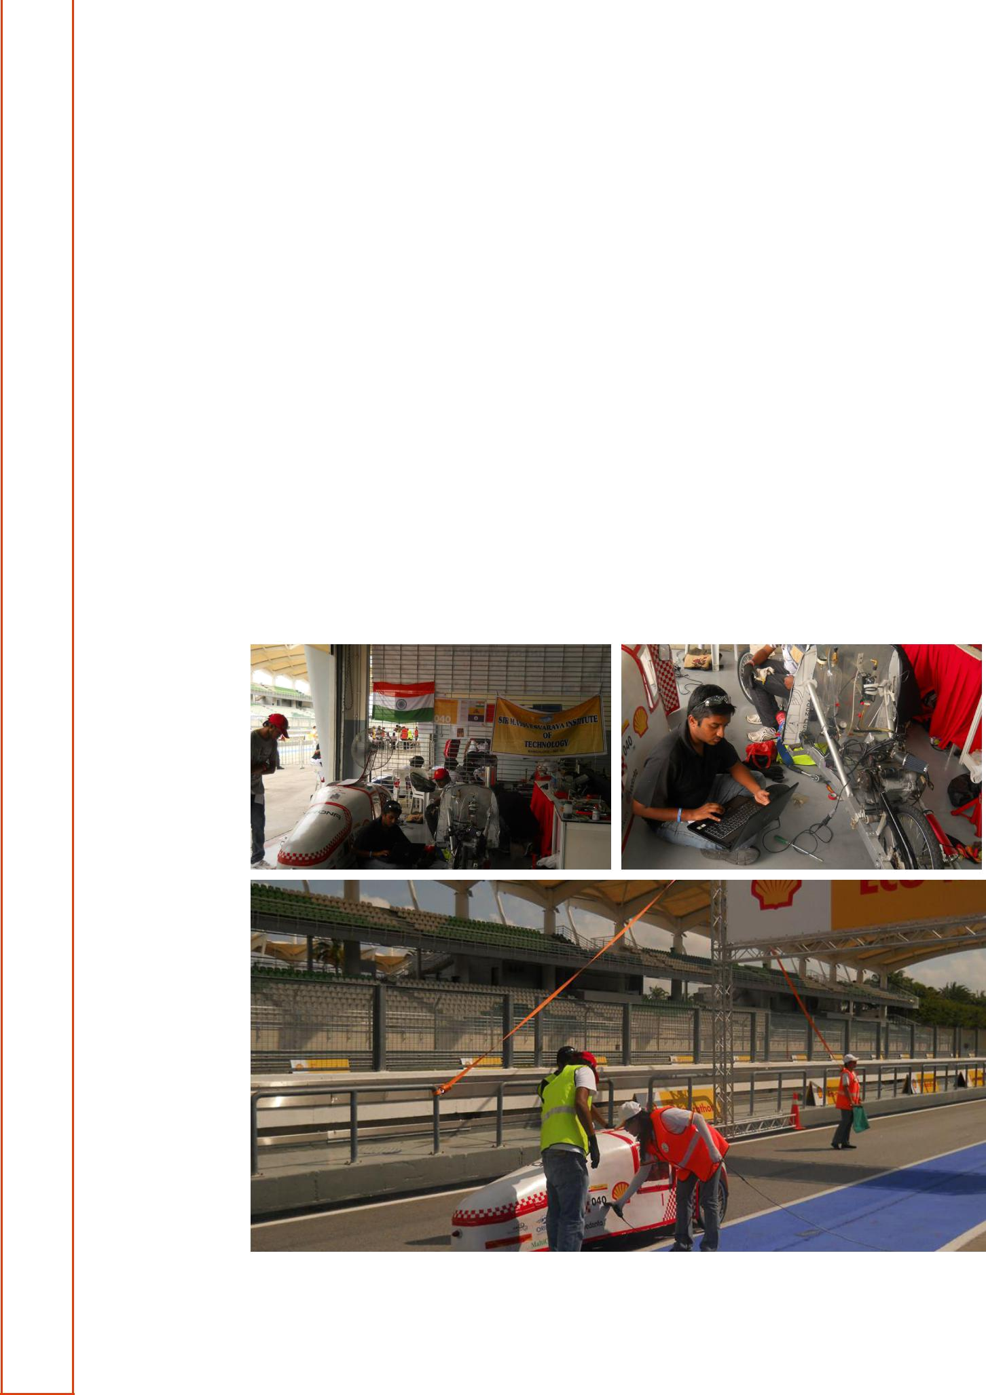

This document and its contents are highly confidential and must never be shared with anyone without procuring a prior written permission of the author. All Right Reserved, Team Inferno. Sir MVIT, Bangalore, India

 | INFERNO
Shell Eco Marathon- More Distance, Less Energy.
Shell Eco Marathon- More Distance, Less Energy. | 4

Depleting oil reserves, spiralling costs and escalating pollution levels has created a necessity for technology that aims to optimize and decrease fuel consumption.

The Shell Eco-marathon is an international competition which challenges student teams from around the world to design, build and test energy efficient vehicles.

Shell, being a major petroleum company, understands the direct consequences of depleted fuel reserves and mounting fuel costs around the world which is one of the prime reasons for the conduction of these events. Annual events are held in the Americas, Europe and Asia, the winner being the team which traverses the furthest distance using the least amount of energy.

This event also presents an outstanding opportunity for intercourse between current and future leaders who are dedicated to this noble initiative.

Shell Eco Marathon, 2017 will be held at Changi exhibition centre, Singapore in the month of march


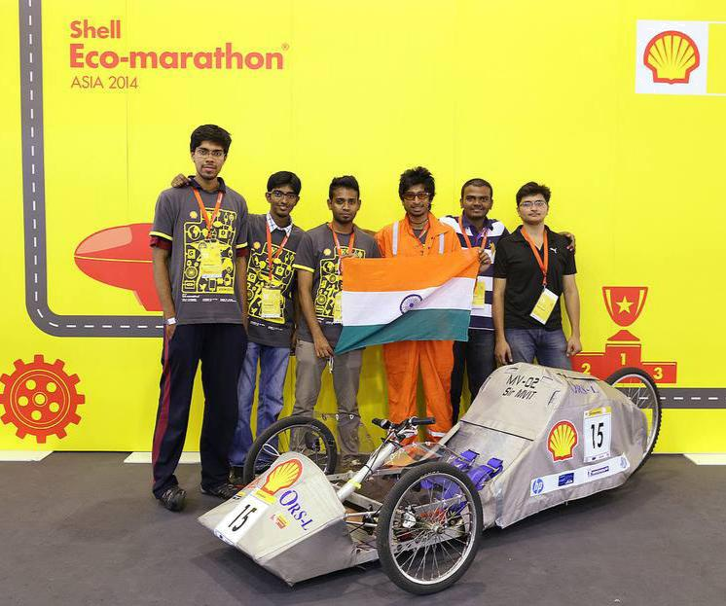

This document and its contents are highly confidential and must never be shared with anyone without procuring a prior written permission of the author. All Right Reserved, Team Inferno. Sir MVIT, Bangalore, India

INFERNO
Our Success Story
5
Our success story has been well documented over the past years under various media outlets:
Past Media Coverage
Following our admirable results at the event in 2012, we were given coverage by IBN-Live, which
Included a showcase of our vehicle along with an interview with the team members. In 2014 the
Team got its first TV coverage courtesy of NEWS9.

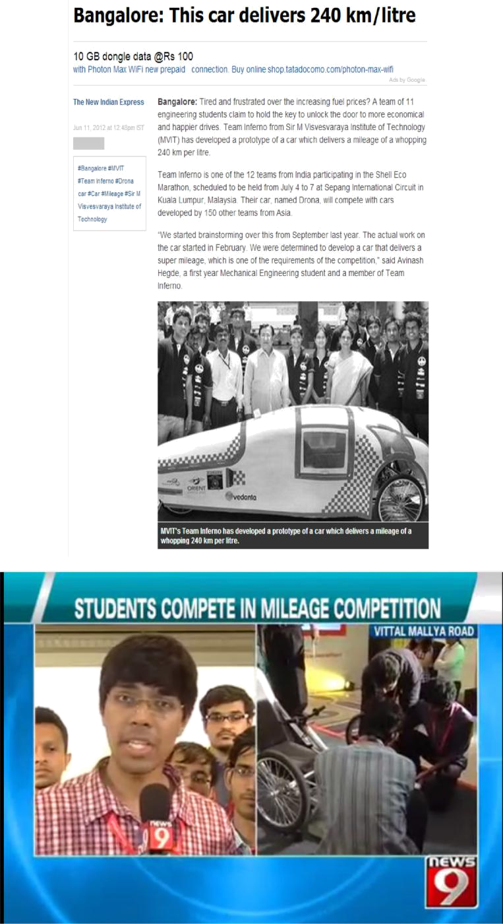

This document and its contents are highly confidential and must never be shared with anyone without procuring a prior written permission of the author. All Right Reserved, Team Inferno. Sir MVIT, Bangalore, India

 |  |  | INFERNO
We also showcased the vehicle at the IMS 2012 (Indian Manufacturing Show), where prominent |  |  | 6
figures of the automotive industry were present; among them was Mr. Anand Mahindra, CEO
Mahindra & Mahindra who lauded our efforts and encouraged us to continue working on our
Research.

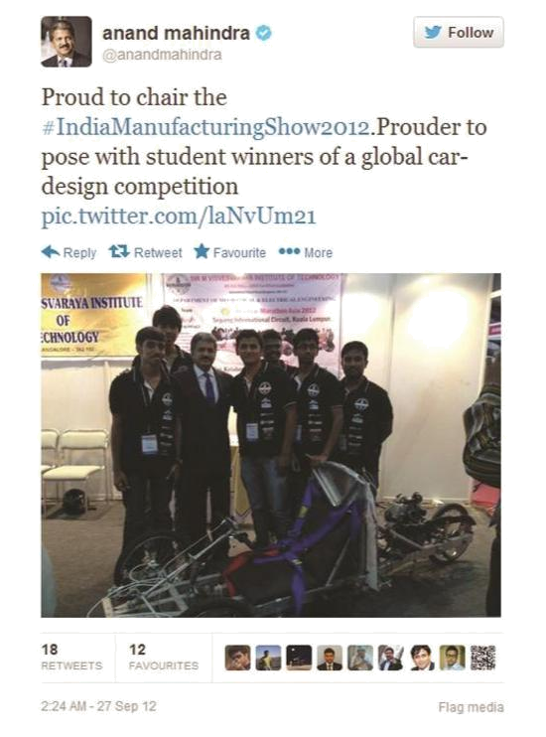

Recognition at the event

We received a cash award of $5000($2000+$3000) from Shell as a result of our satisfactory performance in the safety and technical rounds. We were also recognized as the best team from India to have taken part at the event.

This document and its contents are highly confidential and must never be shared with anyone without procuring a prior written permission of the author. All Right Reserved, Team Inferno. Sir MVIT, Bangalore, India

INFERNO
 | Events
7 | Events

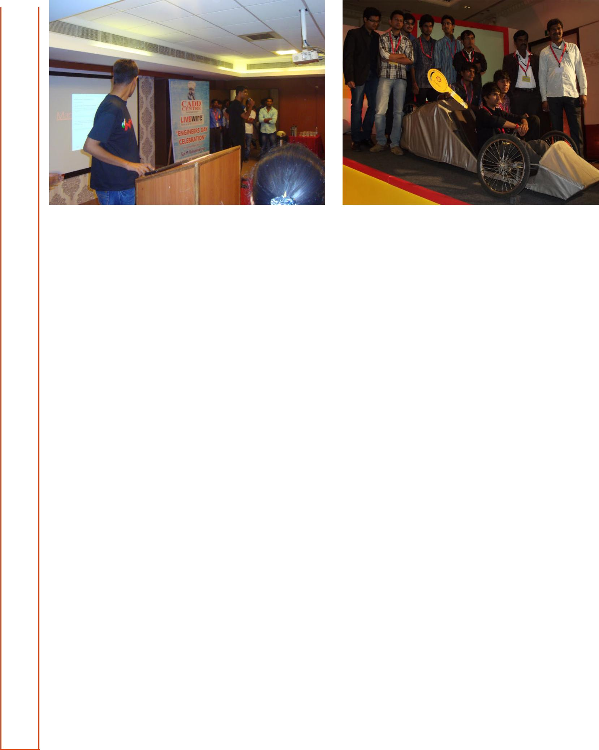

CADD centre presentation 2014 Shell send off party

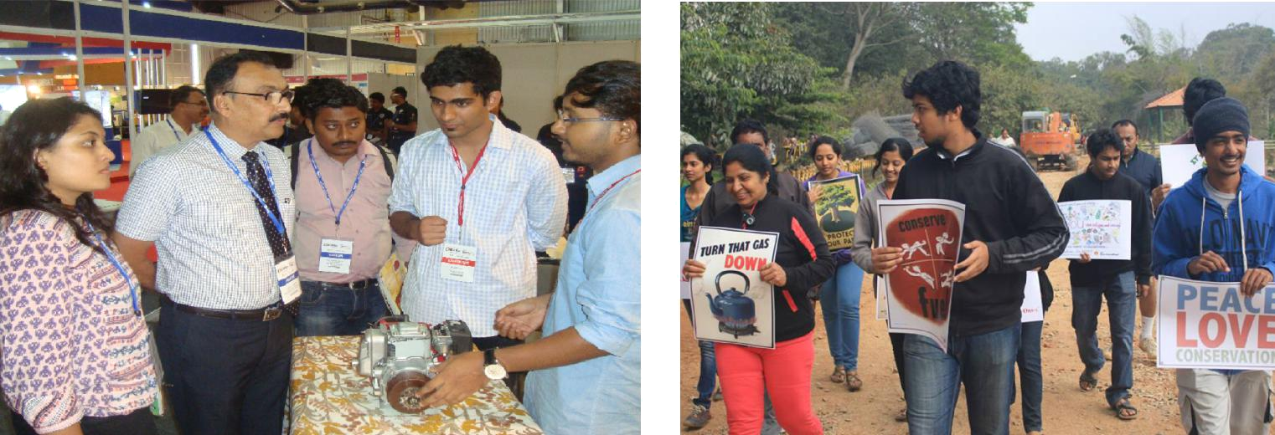

IMS 2014 Eco Awareness Drive

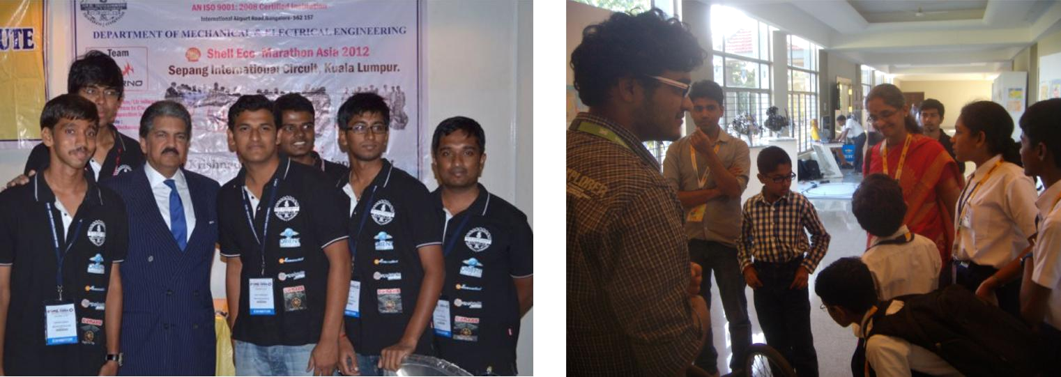

IMS 2012 AWIM 2013

This document and its contents are highly confidential and must never be shared with anyone without procuring a prior written permission of the author. All Right Reserved, Team Inferno. Sir MVIT, Bangalore, India

Achievement of 2016

Team INFERNO successfully participated in SHELL ECO MARATHON Asia-2016 held in Manila, Philippines between March 03-07, 2016 and achieved 9th place in Asia and the only Indian team to be placed in top 10 in the Gasoline Prototype category

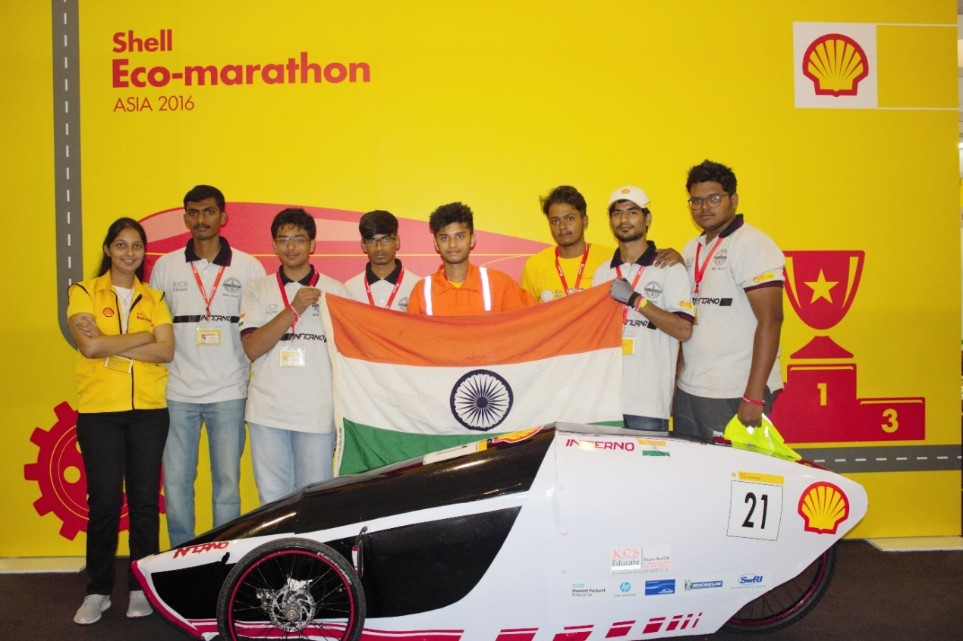
.

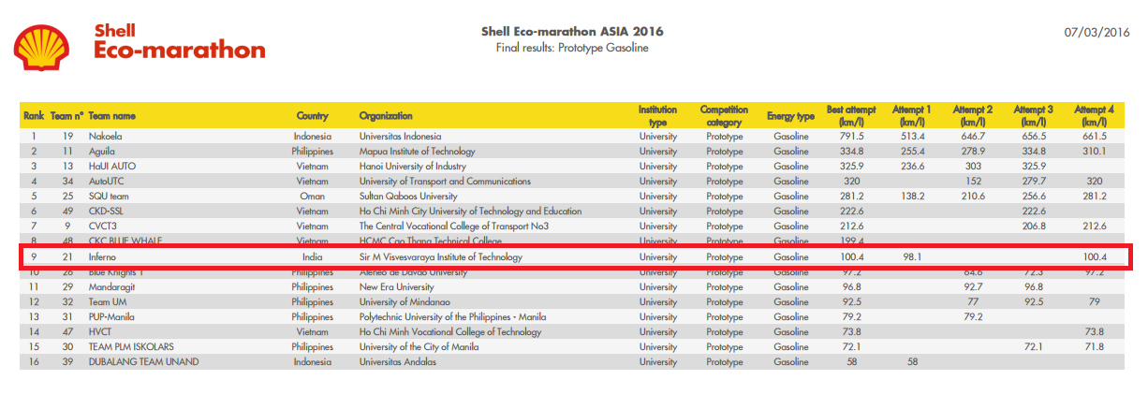

8
Key Features of DHRUVA- Our 2017 Vehicle

Keeping in mind the ever developing automotive sector, we are now working towards enhancing the overall performance of the vehicle- safety, technical aspects of the car and the aesthetics. The key areas of improvement are:

- Optimizing chassis design resulting in weight reduction (Aluminium Chassis)

- Engine modifications

- Sophisticated fuel delivery system

- Optimizing power-train / transmission

- Overall weight reduction

- Enhancing the safety features

- Reducing friction

- Utilization of quality, precision manufacturing

- Polycarbonate has been chosen to make the outer body due to its light weight, high impact strength and high resistance to temperature changes around it.

Our 2017 Design

INFERNO
8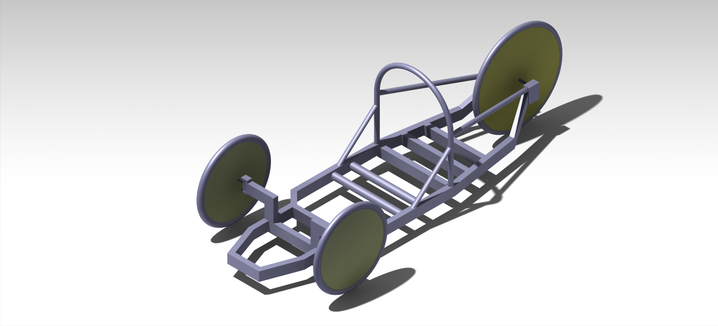

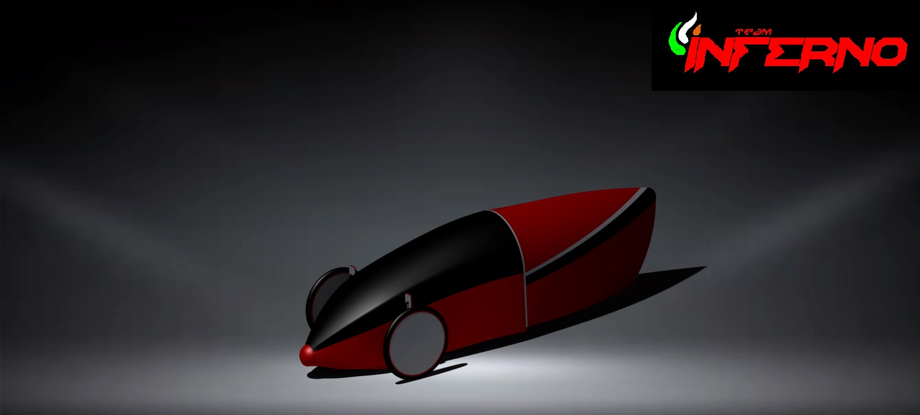

This document and its contents are highly confidential and must never be shared with anyone without procuring a prior written permission of the author. All Right Reserved, Team Inferno. Sir MVIT, Bangalore, India

INFERNO

9

Budget Requirements and Allocation for 2017

Based on our previous experience, we have determined the minimum requirements for the upcoming car. The budget given below is an outline of the costs which may be incurred throughout the production of the car which factors in the engine tuning processes along with the amount necessary for travelling to Singapore, where the event will be held.

Sl No. | Particulars | Allocation
1 | ECU Purchasing, Tuning (Professional Help Included) | INR 90,000.00/-
2 | Procuring and Modifying Engines (Primary and Spare) | INR 40,000.00/-
3 | Chassis analysis and Fabrication | INR 35,000.00/-
4 | Powertrain and Miscellaneous | INR 50,000.00/-
5 | Outer Shell (Mould + FRP Body) | INR 90,000.00/-
6 | Shipping (Freight Forwarding + Safety Packaging) | INR 3,50,000.00/-
7 | Travel, Stay and Other Expenses in the Philippines | INR 2,80,000.00/-
8 | Spares and Equipment’s | INR 50,000.00/-
9 | Trial Runs and Troubleshooting | INR 60,000.00/-
 | Total | INR 9,95,000.00/-



This document and its contents are highly confidential and must never be shared with anyone without procuring a prior written permission of the author. All Right Reserved, Team Inferno. Sir MVIT, Bangalore, India

10

Sponsorship Opportunities & Benefits

We treat the competition as an opportunity where we may grow in our approach and maximize our capabilities. For this, we require your coordination and support. As may be expected from such a venture of balanced interests, the following are the opportunities that sponsors may expect:

- Press release/ Media coverage: Print and other Media, Television, Internet and Radio.

- Brand coverage in publicity drives/events/exhibitions in India (Logo on vehicle and sponsor’s banner at pit)

- Brand presence at the event in Philippines (Logo on vehicle and sponsor’s banner at pit)

- Sponsor’s profile in team brochures, reports, team website, team’s Facebook page and college magazine (readers include students, alumni, parents and trustees).

- Publicity/ Coverage at events that are held on campus (college festivals, fresher’s day, etc.) along with other avenues.

- Sponsor’s banner at vantage points during Sir MVIT’s inter-collegiate festival-Kalanjali. In which students from over 40 colleges across the state take part (Footfall=10000+).

- Positive Social and economic impact.

- Commercialization possibilities- Possible implementation of research in the commercialization and mass production.

- Industry-academia relationship.

- Innovative engineering and high fuel economy research.


This document and its contents are highly confidential and must never be shared with anyone without procuring a prior written permission of the author. All Right Reserved, Team Inferno. Sir MVIT, Bangalore, India

INFERNO

11

Exploring your options- Our Packages

 | Diamond | Platinum | Gold | Silver
 | INR 4,00,000 | INR 2,50,000 | INR 1,00,000 | INR 50,000
Video of Vehicle+ | ✓
Brand Ad for TV | ✓
News Channels | ✓
Sponsor | ✓
dedicated event | ✓
Highlighted | ✓ | ✓
in press release | ✓ | ✓
Logo on T-shirt | ✓ | ✓
& Merchandise | ✓ | ✓
Publicity at all | ✓ | ✓ | ✓
events / | ✓ | ✓ | ✓
Exhibitions | ✓ | ✓ | ✓
Sponsor’s | ✓ | ✓ | ✓
banner in pit | ✓ | ✓ | ✓
at the event | ✓ | ✓ | ✓
Logo on Vehicle | ✓ | ✓ | ✓ | ✓
Logo on banner | ✓ | ✓ | ✓ | ✓
for all events
at college
Publicity on | ✓ | ✓ | ✓ | ✓
team page
& website


This document and its contents are highly confidential and must never be shared with anyone without procuring a prior written permission of the author. All Right Reserved, Team Inferno. Sir MVIT, Bangalore, India

INFERNO

Our Partners

All our past achievements have been made possible only by the sustained cooperation and continued assistance lent ¹² to us by:

















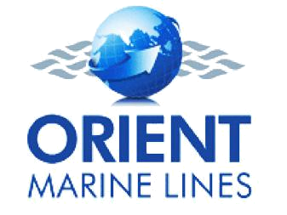

This document and its contents are highly confidential and must never be shared with anyone without procuring a prior written permission of the author. All Right Reserved, Team Inferno. Sir MVIT, Bangalore, India

INFERNO
13 | An Appeal
 | Team Inferno strives to be the best in the field of revolutionizing the way fuel is consumed today and
 | also to achieve path breaking results whilst maintaining a reduced carbon footprint. As a participant,
 | our primary goal is to be a serious contender in the Shell Eco Marathon.
 | In the process we hope to develop novel and innovative techniques that can serve as practical solutions
 | to pressing needs of optimizing fuel utilization. This dream can be realized more meaningfully by the
 | willing contributions of sponsors.
 | The venture, we hope, will help us realize our dream of bringing our research into the market and
 | make cheap transportation a reality.
 | We await a positive response and hope that together, we may be able to start a fruitful alliance.
 | We look forward to meeting you and your company for the presentation which will include a more
 | detailed overview of our project.
 | Respectfully,
Sumeet B Patil
Team Manager
M: +91-8495038383

 | K. Ejaz Ahmed
 | Project guide
 | M: +91-9845450080 | Email id: ejazak_65@yahoo.co.in
 | Team Inferno
 | Sir M.Visvesvaraya Institute of Technology.
 | Krishnadevaraya Nagar, Off International Airport Road,
 | Bangalore, Karnataka, India.

This document and its contents are highly confidential and must never be shared with anyone without procuring a prior written permission of the author. All Right Reserved, Team Inferno. Sir MVIT, Bangalore, India

